SIMATS ENGINEERING (SAVEETHA SCHOOL OF ENGINEERING)
Department of Computer Science and Engineering
CO2_AT2 — VISUALIZATION DEVELOPMENT EXERCISE

Course Code: | DSA06 | Course Title: | Data Handling and Visualization
CO Assessed: | CO2 – Development (BL4) | Assessment: | Assessment Tool 2 – Visualization Development
Weightage: | 20% of CIA | Total Marks: | 25 (5 Questions × 5 Marks)
CO2 Statement: | Analyze and synthesize multiple data views into a coherent, annotated dashboard that communicates a clear narrative insight.(BL4)
Student Name: | Haritha S | Reg. No.: | 192324299
Section / Batch: | B.tech – AI&DS | Date: | 30/07/2026

Code of Conduct
I __________________________ (Name / Reg No) certify that this submission is my original work and that I have adhered to the guidelines specified for this assessment. I understand that any violation of academic integrity rules will result in disciplinary action.

Signature of the Student: _________________________

Instructions
- This test contains 5 questions, each carrying 5 marks. Total: 25 Marks.
- No negative marking. Unanswered questions carry zero marks.
- No calculators or electronic devices permitted.
- Duration: 90 minutes.
- Each answer must include at least two coordinated charts sharing a common axis or theme.
- Include at least one annotation calling out a key data point in your dashboard.
- Write a one-sentence narrative takeaway summarizing the insight your dashboard reveals.

Annexure A – VISUALIZATION DEVELOPMENT

Rubrics for Calculation ASSESSMENT RUBRIC
AT2 — Visualization Development Exercise
CO2 · BT4: Analyze ·
This rubric is used to assess student responses to the CO2-AT2 Visualization Development Exercise, in which students build a small multi-chart dashboard from given data, add at least one annotation, and write a narrative takeaway.

Criteria | Weightage | Level 4 – Exemplary | Level 3 – Proficient | Level 2 – Developing | Level 1 – Beginning
Understanding of Concepts | 25% | Demonstrates thorough understanding of which chart types to combine, how they relate to each other, and how annotation and narrative should be used to communicate insight. | Good understanding of chart combination and annotation/narrative technique, with only minor gaps. | Basic understanding of dashboard development, but with some misconceptions about which charts to combine or how to annotate them. | Poor understanding of core development concepts; combines charts or annotations that do not suit the data or the story being told.
Explanation | 25% | The annotation and narrative takeaway are precise, well-justified, and clearly tied to a specific, correctly identified data point or pattern. | The annotation and narrative are clear and reasonably well-justified, with adequate connection to the data. | The annotation or narrative is present but vague, generic, or weakly connected to the actual data shown. | Annotation or narrative is missing, incorrect, or unconnected to the data in the dashboard.
Application | 20% | Effectively applies multi-chart coordination, annotation, and storytelling techniques to produce a complete, cohesive dashboard for the scenario. | Applies development techniques to produce a workable dashboard, with only minor errors or missed refinements. | Limited application; the dashboard partially addresses the scenario but charts feel disconnected or the story is unclear. | Fails to apply appropriate development techniques; the charts, annotation, and narrative do not work together as a dashboard.
Organization | 15% | Charts are clearly coordinated (aligned axes or shared theme), laid out logically, with the annotation and narrative placed for maximum clarity. | Charts are organized and mostly coordinated, with only minor issues in alignment or layout. | Basic structure; charts are present but poorly aligned or the annotation/narrative feels disconnected from the layout. | Poorly organized; charts are not coordinated, and the annotation or narrative is missing or misplaced.
Accuracy | 10% | All chart values, scales, and the annotated data point are completely accurate and correctly reflect the given data. | Mostly accurate, with only minor omissions or a small error in one chart or the annotation. | Partially correct; some plotted values or the annotated point are missing or incorrect. | Largely inaccurate; major errors in plotted values, scales, or the annotated data point.

Scoring Guide
For each criterion, award a performance level (1–4) based on the descriptors above. Multiply the level achieved (as a percentage of 4, i.e., Level 4 = 100%, Level 3 = 75%, Level 2 = 50%, Level 1 = 25%) by the criterion's weightage, then sum across all five criteria to obtain the total score out of 100%.

Faculty In-charge | Course Coordinator | Head of Department
Signature: _______________ | Signature: _______________ | Signature: _______________
Date: ___________________ | Date: ___________________ | Date: ___________________

Problem 3 — Hospital Patient Flow Dashboard (5 Marks)
Data: Daily admissions and average wait time: Mon = 40 / 35 min, Tue = 55 / 50, Wed = 60 / 65, Thu = 45
/ 40, Fri = 70 / 80.
Task: Build a dashboard with a bar chart of admissions and a line chart of wait time on the same day
axis. Add an annotation flagging the day needing urgent staffing attention, and write a one-sentence
takeaway for hospital management.

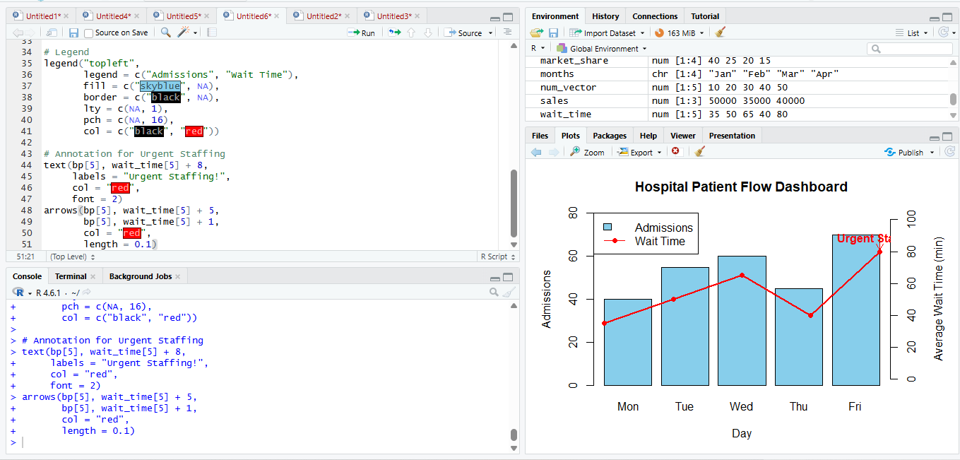

Problem 4 — School Performance Dashboard (5 Marks)
Data: Average test score and attendance rate by grade: Grade 6 = 72% / 91%, Grade 7 = 68% / 85%,
Grade 8 = 75% / 93%, Grade 9 = 60% / 78%.
Task: Build a dashboard combining a bar chart of average scores and a bar chart of attendance rate for
the same grades. Annotate the grade needing intervention, and add a short narrative connecting
attendance to performance.

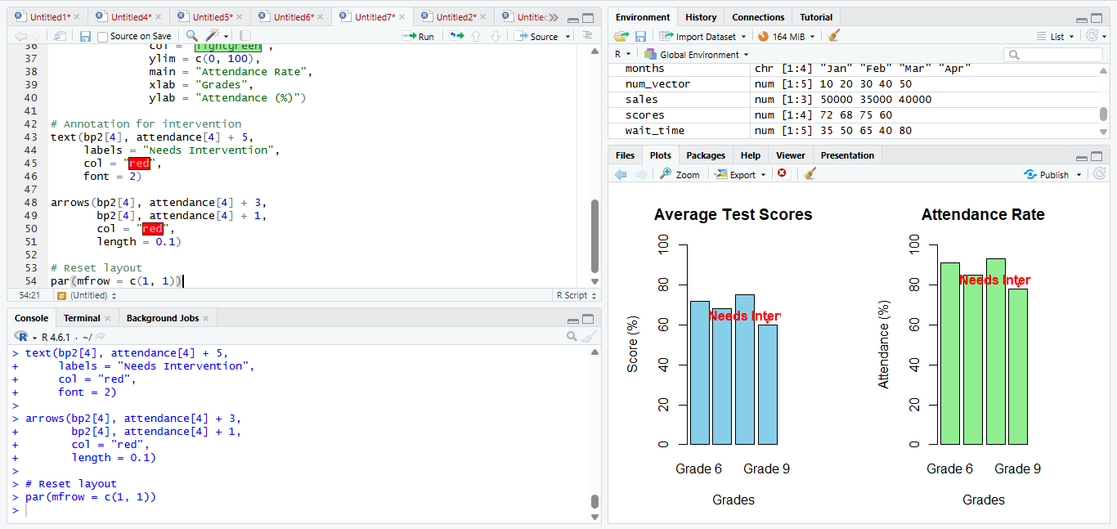
Problem 5 — E-commerce Product Dashboard (5 Marks)
Data: Units sold and return rate for 5 products: A = 500 units / 5% returns, B = 350 / 12%, C = 600 / 3%,
D = 200 / 20%, E = 450 / 8%.
Task: Build a dashboard with a bar chart of units sold and a bar chart of return rate for the same products. Annotate the product with a concerning return rate despite strong sales, and write a takeaway
recommending an action.

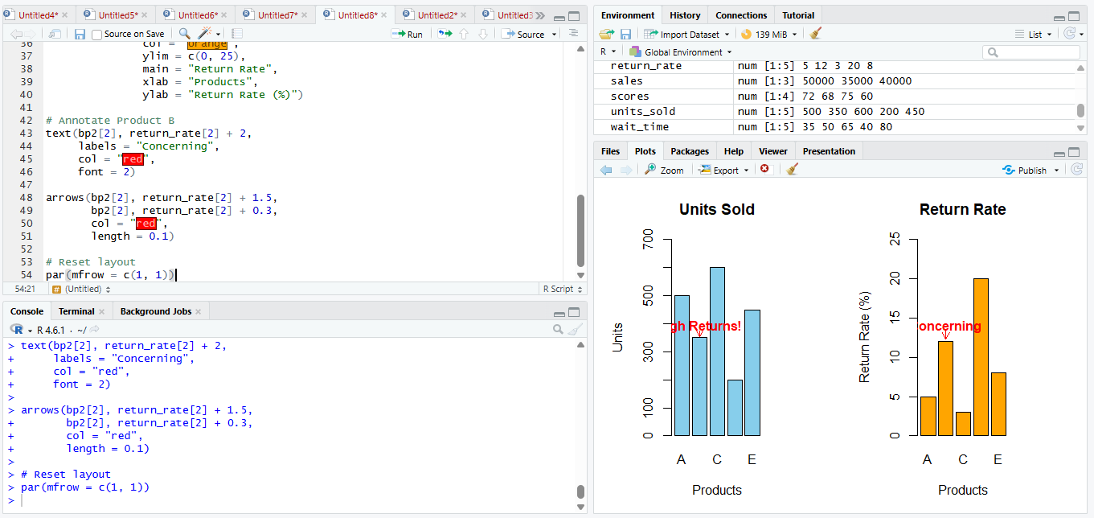

Problem 6 — Social Media Growth Dashboard (5 Marks)
Data: Monthly followers and engagement rate: Jan = 1,000 / 3%, Feb = 1,200 / 3.5%, Mar = 1,500 / 2%,
Apr = 1,800 / 4%, May = 2,200 / 3%, Jun = 2,800 / 5%.
Task: Build a dashboard with a line chart of follower growth and a line chart of engagement rate on the
same month axis (stacked, not dual-axis). Annotate the month where engagement diverged notably
from follower growth, and write a one-sentence narrative interpreting this.

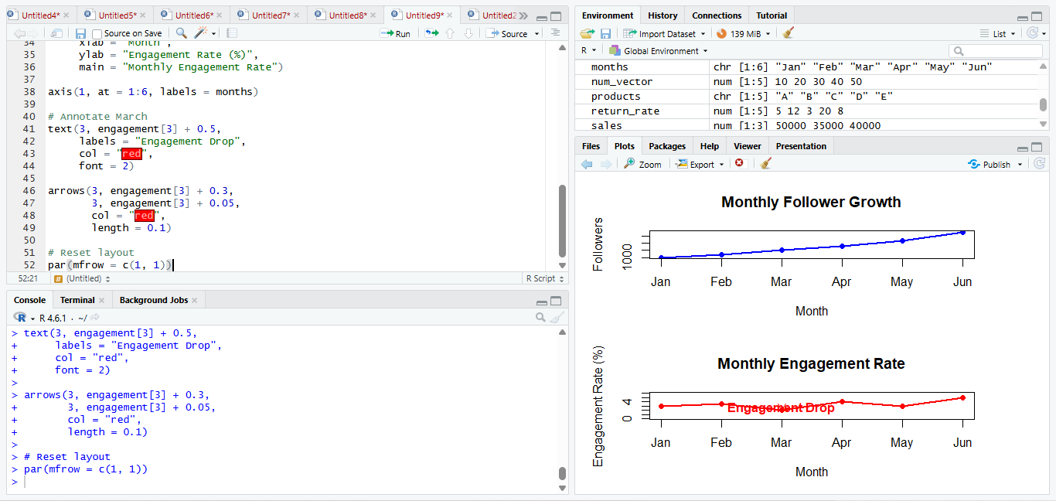
Problem 7 — Manufacturing Quality Dashboard (5 Marks)
Data: Defect rate and production volume by line: Line 1 = 2% / 1,000 units, Line 2 = 5% / 1,200, Line 3 =
1% / 800, Line 4 = 8% / 1,500, Line 5 = 3% / 900.
Task: Build a dashboard with a bar chart of production volume and a bar chart of defect rate for the
same lines. Annotate the line requiring immediate quality review, and add a takeaway for the plant
manager.

